REPORT ON MINI PROJECT

NAME : DEEPTHI B

BATCH NUMBER : TN_BN_FNB07

MOBILE NUMBER : +91 99521 40825

MAIL ID : deepthird0225@gmail.com

PROJECT NAME : Mental Health in Social Medial data

PROJECT DOMAIN : Social Media

SUBMISSION DATE : 10.12.2025

MENTOR NAME : M. Kumaran

RAW DATASET LINK : Social Media Mental Health Indicators Dataset

CLEANED DATASET LINK: Deepthi25B/Social-media-mini-project

MENTAL HEALTH SOCIAL MEDIA ANALYSIS PROJECT REPORT

INTRODUCTION:

Social media has become an integral part of everyday life, especially among young adults. While it provides opportunities for communication, entertainment, and information sharing, it can also influence mental health in significant ways. Understanding how digital behavior such as screen time, social media usage, online interactions, and engagement patterns affects mental well-being is crucial.
This dataset captures key variables including daily screen time, social media usage hours, negative & positive interactions, sleep duration, physical activity, anxiety level, stress level, mood level, and mental state. By analyzing these factors, the project aims to uncover meaningful insights into how social media behaviors correlate with mental health indicators.

PURPOSE OF THE PROJECT:

The primary purpose of this project is to analyze the relationship between social media usage patterns and mental health outcomes. With growing concerns about stress, anxiety, poor sleep, and reduced physical activity among frequent social media users, this study aims to:
- Identify patterns linking screen time and mental health issues
- Understand how interaction quality (positive vs negative) impacts emotional well-being
- Explore how lifestyle factors (sleep, activity level) correlate with anxiety, stress, and mood
- Provide data-driven insights that can support mental health awareness and digital wellness practices
This project serves as a foundation for detecting early signs of deteriorating mental health and promoting healthier social media usage habits.

AIMS:

The project aims to produce:
- A clean and well-structured dataset
- Descriptive analytics showing trends and distributions
- Correlations between digital behavior and mental well-being
- Actionable insights that can help users improve their digital habits
- Visual dashboards that explain patterns clearly
Ultimately, the goal is to understand how social media impacts mental health and support recommendations for digital wellness.

OBJECTIVES OF THE PROJECT:

- To clean and prepare the mental health social media dataset.

- To Analyze how variables such as daily screen time, social media hours, and interaction quality (positive/negative) influence anxiety, stress, and mood levels.

- To build interactive visualizations and KPIs using Power BI.

- To identify the high, medium and low stress category.

- Examine the role of sleep duration and physical activity in balancing the negative effects of heavy social media use.

- To generate insights using charts, maps, and filters.

DATA DESCRIPTION:

The dataset contains Mental health social media parameters:
Person name, Age, Date, Gender, Platform, Daily screen time hours, social media time hours, Screen time activity, Negative and positive interaction count, sleep hours and anxiety and mood level.
The dataset was initially unclean and contained duplicated records, inconsistent date formats and missing values.

PROBLEM STATEMENT:

The Mental health and social media dataset were messy and unstructured, making it difficult to analyze.
The challenge was to clean the data, remove inconsistencies, handle missing values, and convert it into a usable format for meaningful visual insights.

MISSION OF THE PROJECT:

The mission of this project is to analyze and transform Mental health and social media dataset into meaningful insights, enabling better understanding and promote digital well-being by analyzing how social media usage patterns impact mental health.
Through data-driven insights, the project aims to identify early signs of stress, anxiety, and poor emotional balance, helping individuals develop healthier online behaviors.

DATA CLEANING IN DATA SET

Convert given dataset into table
The entire dataset was first converted into a proper structured table/range. By selecting the range ctrl+a and click insert tab - select Table option.
Raw dataset :
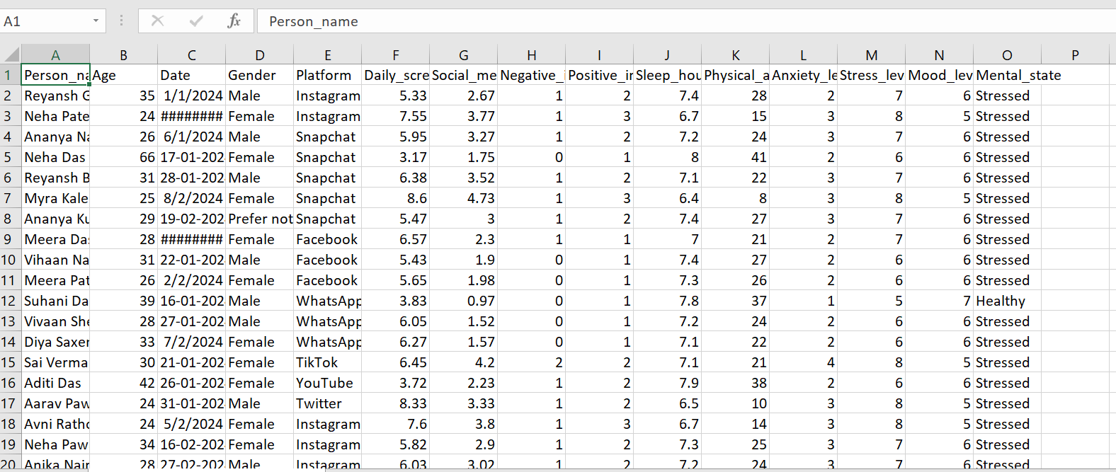
After inserting table :
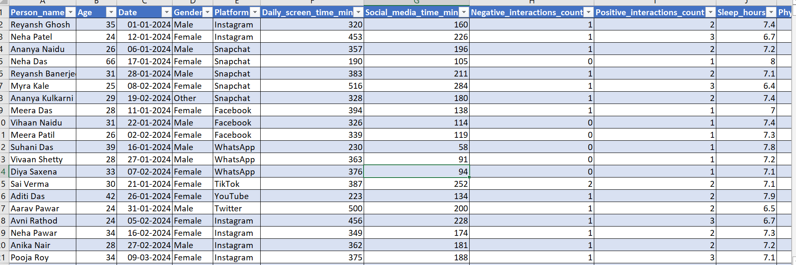
Removed duplicates:
- The dataset contained duplicate records based on key fields.
- Identified and removed duplicate entries using Excel’s Remove Duplicates feature.
- In Data tab, clicked Removed duplicates by selecting Person name, 866 duplicate found and 4134 unique values remains.

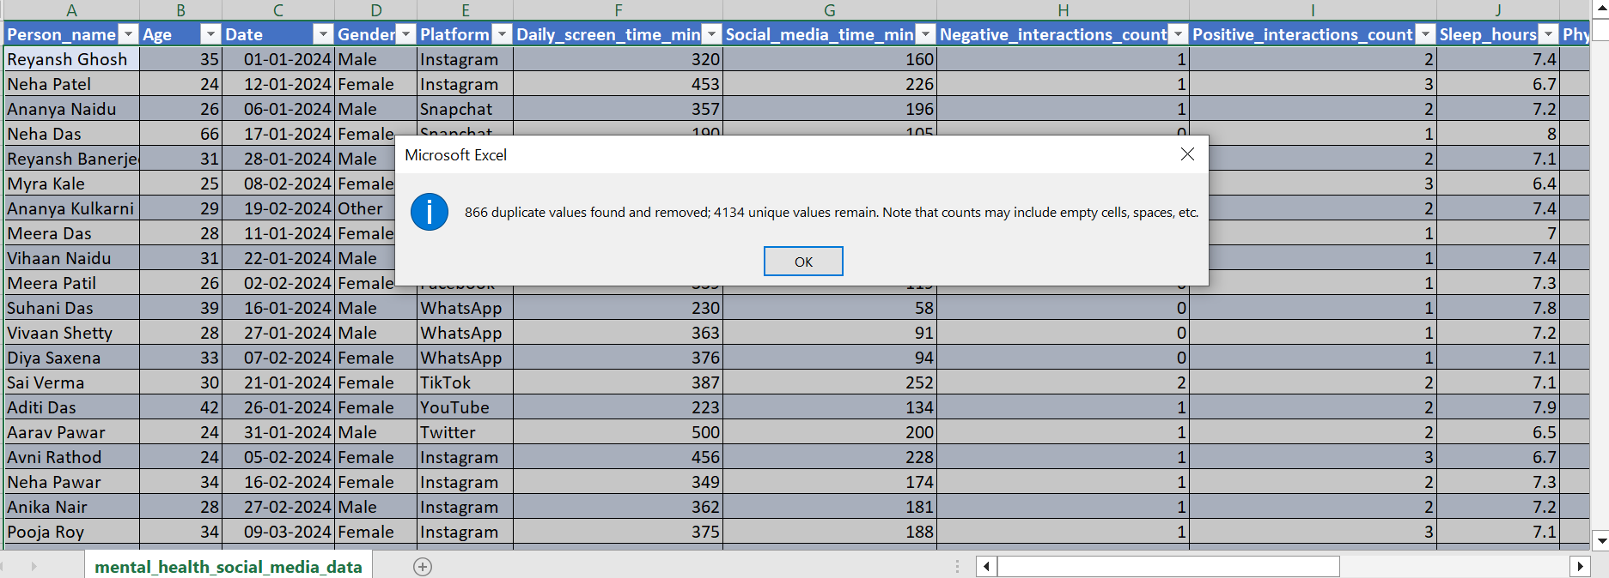

Inconsistent Data column:

The Date column contained inconsistent date formats, using both Slash and Hyphen format. Standardized all date entries by converting slashes (/) to hyphens (-).

Original column  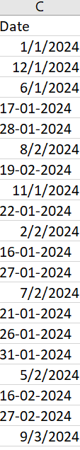 | Standardized column  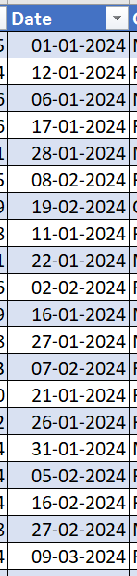

Age Column:
Problem identified:
The dataset contained only raw age values, which made it difficult to analyze patterns between children vs adults.
Action Taken:
Created a new Age Category column by classifying users based on their age. Used a simple rule Child: Age < 18 and Adult: Age ≥ 18.
Steps followed:
  - Identify the Age Column
  - Create a New Column Named Age Category.
Formula used :
Age category =IF(B3<18,"Child","Adult")

Original Value  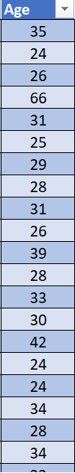 | Standardized value  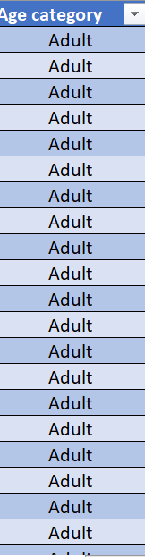

Geder column:
Problem identified:
The Gender column contained three values: Male, Female, and Other. The label “Other” was not appropriate for reporting and could be considered inconsistent or unclear.

Action Taken:
  - Replaced the value “Other” with the more appropriate and inclusive label “Prefer Not to Say”.
  - Ensured the Gender column now contains only:
- Male
- Female
- Prefer Not to Say
Steps followed:
Reviewed the Gender column and found the entry "Other" and replaced by Home → Find & Select → Replace.

Original Value  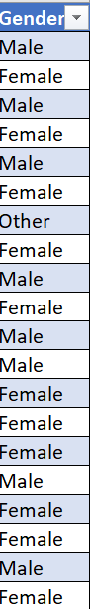 | Standardized value  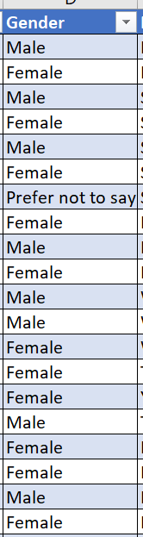

Daily screen time and social media screen time :
Problem identified :
The dataset contained Daily Screen Time and Social Media Screen Time in minutes. Some values were inconsistent or required transformation and minutes > 60 needed to converted to proper hour format.
Action Taken:
Converted both Daily Screen Time (mins) and Social Media Screen Time (mins) into Hours using Excel formulas.
Steps followed:
Using two column I have created new column Daily screen time hours and Social media time hours.

Original value  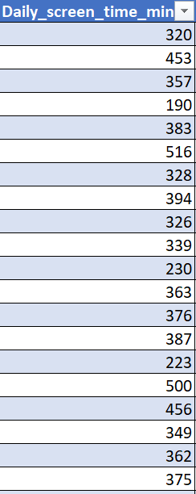  Original value  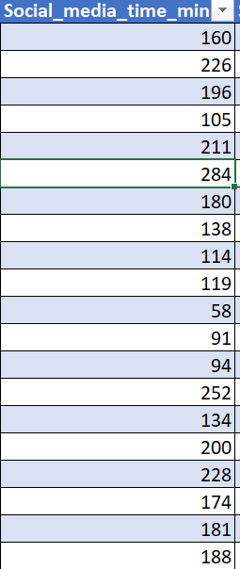 | Standardized value  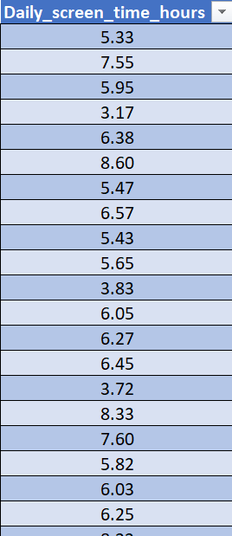  Standardized value  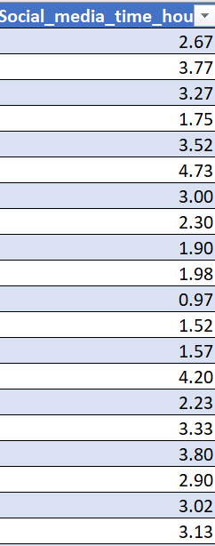

Formula used :
= Minutes / 60
= F2 / 60

Screen time activity:
Problem identified:
The dataset had two separate time fields Daily screen time and social media time because these values are stored separately. To understand a person’s total screen exposure a combined Screen Time Activity column was required.

Action Taken:
Created a new column named Screen Time Activity by adding:
- Daily Screen Time Hours
- Social Media Screen Time Hours.
Steps followed:
Converted all screen minutes to hours and created a new column called Screen time activity.

Original value  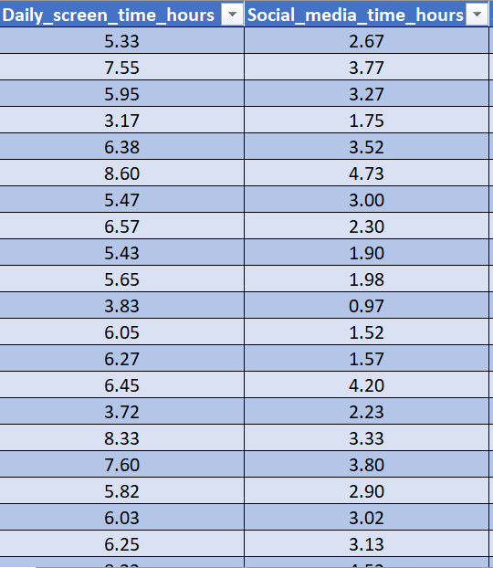 | Standardized column  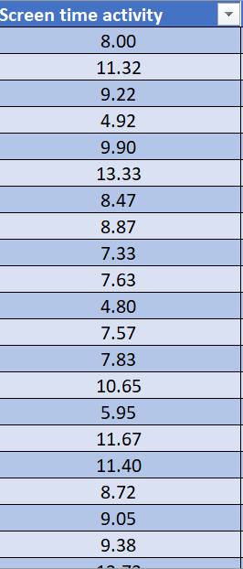

Formula used :
= (G2 + H2)
Total interaction count:
Problem identified:
The dataset contained Positive Interaction Count and Negative Interaction Count as separate columns, but there was no single metric representing overall user engagement.

Action Taken:
A new calculated column named Total Interaction Count was created. The formula combined both Positive and Negative interactions to represent complete user engagement.

Steps followed:
Identified required columns and created as new calculated column called Total interaction count.

Formula used:
= (J2) + (H2)

Original value  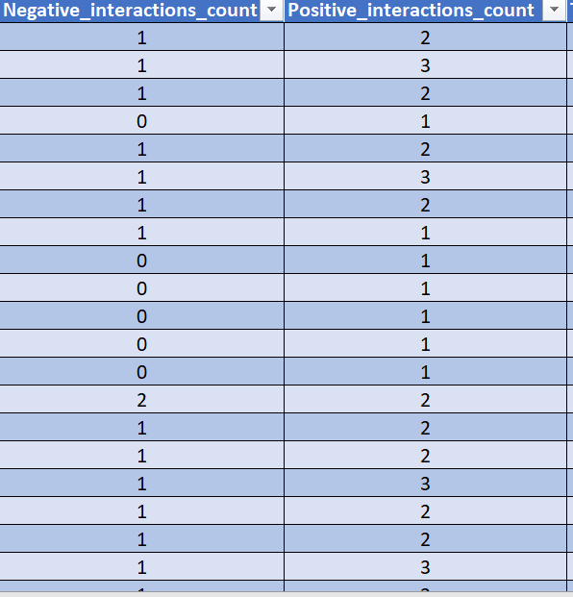 | Standardized value  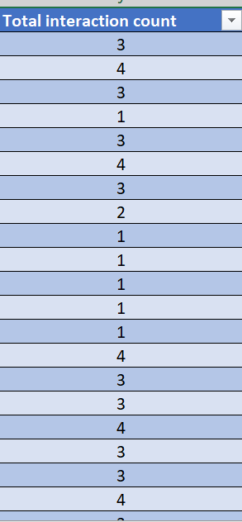

Sleep Quality column:
Problem identified:
The dataset only contained Sleep Hours, but there was no categorized metric to measure sleep quality.
Action taken:
Sleep hours were classified into categories:
- < 6 .5 hours → Poor
- 6–8 hours → Normal
- > 8 hours → High
Steps Followed:
Identified and created a new column called Sleep Quality and applied IF formula to categorize Sleep hours.
Original value  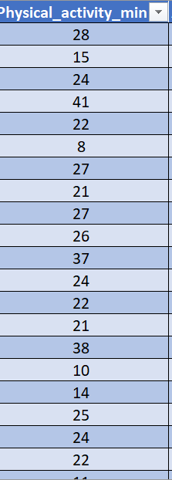 | Standardized value  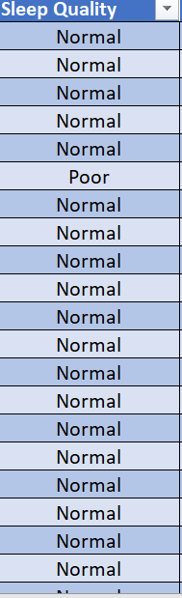

Formula used:
= IF (M2 < 6.5, "Poor", IF (M2 <= 8, "Normal", "High"))

Activity Category column.
Problem identified:
The dataset only had Physical Activity (minutes) as a numeric value, which did not provide clear insight into users' activity levels. Without categories like Sedentary, Moderate, or Active, it was difficult to analyze the physical activity.
Action Taken:
A new column named Activity Category was created. Physical activity was classified into meaningful categories:
- < 20 min → Sedentary
- 20–40 min → Moderate
- > 60 min → Active.
Steps Followed:
Identified and created a new column called Activity category and applied IF formula to categorize.
Formula used:
= IF (O3 < 20, "Sedentary", IF (O3 <= 40, "Moderate", "Active"))

Original value  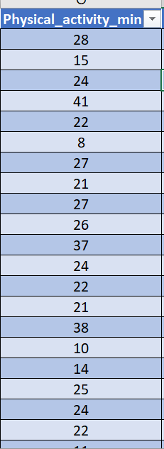 | Standardized value  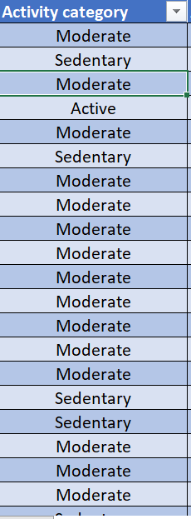

Stress Category:
Problem Identified:
The dataset contained only numeric stress scores (0–10), which did not clearly show whether a person’s stress was low, medium, or high. Raw numerical values made it difficult to analyze stress distribution.
Action taken:
A new classification column called Stress Category was created. Stress scores were grouped into meaningful ranges:
- 0–5 → Low
- 4–7 → Medium
- 8–10 → High
Steps Followed:
Created and inserted a new column called Stress category and applied a nested IF formula to categorize.
Original value  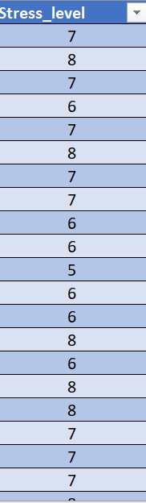 | Standardized value  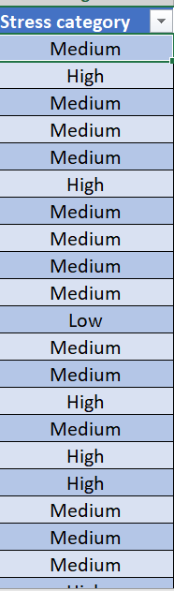

Formula used:
= IF (R2 <= 5, "Low", IF (R2<= 7, "Medium", "High"))

Find & Replaced:
The Mental State column contained inconsistent text values such as At_risk with an underscore. Replaced the incorrect value At_risk with the correct, readable format At risk.

Original value  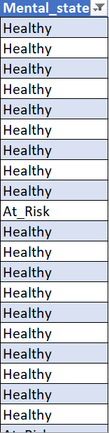 | Standardized value  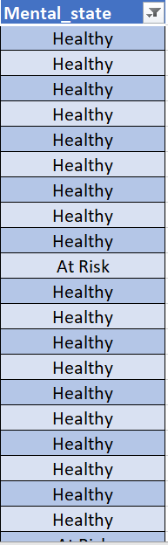

Using power bi I have taken platform count:
Selecting the column and group by - Count rows.

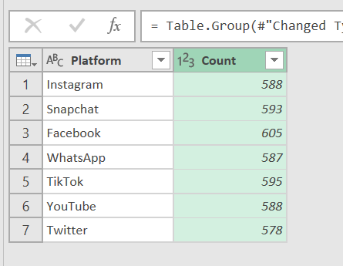

After cleaning the dataset, Pasted the cleaned dataset in new Sheet

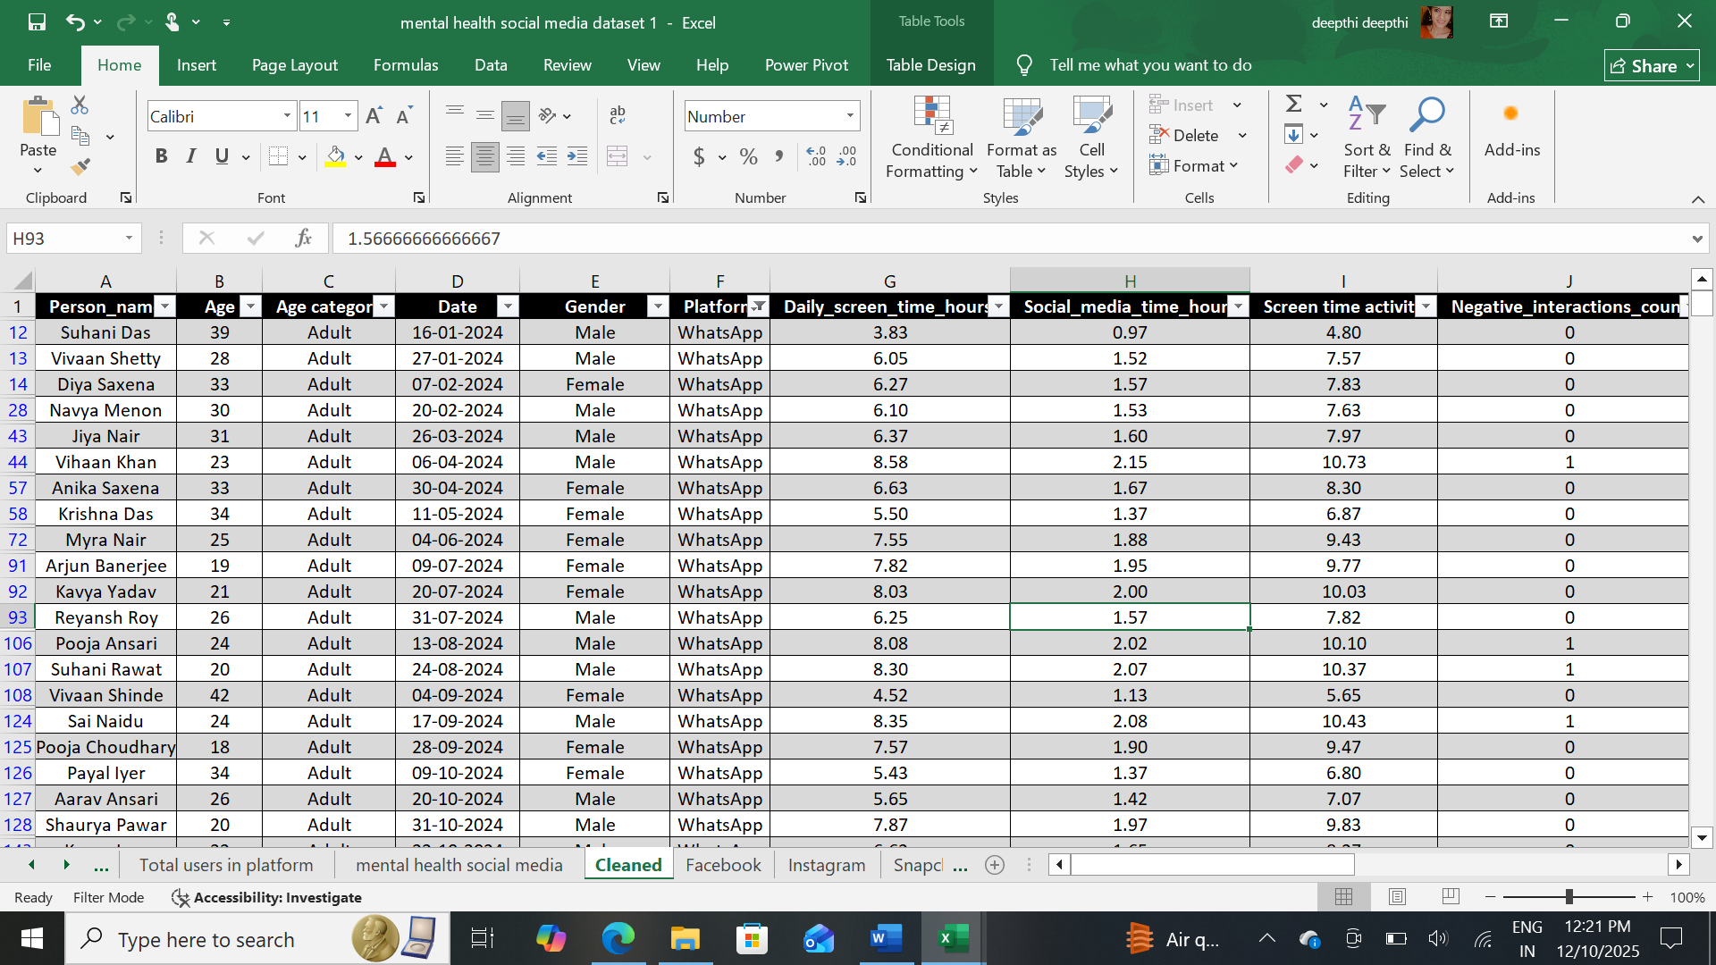

Created Some tables Instagram, WhatsApp, Facebook and Snapchat.
Facebook:
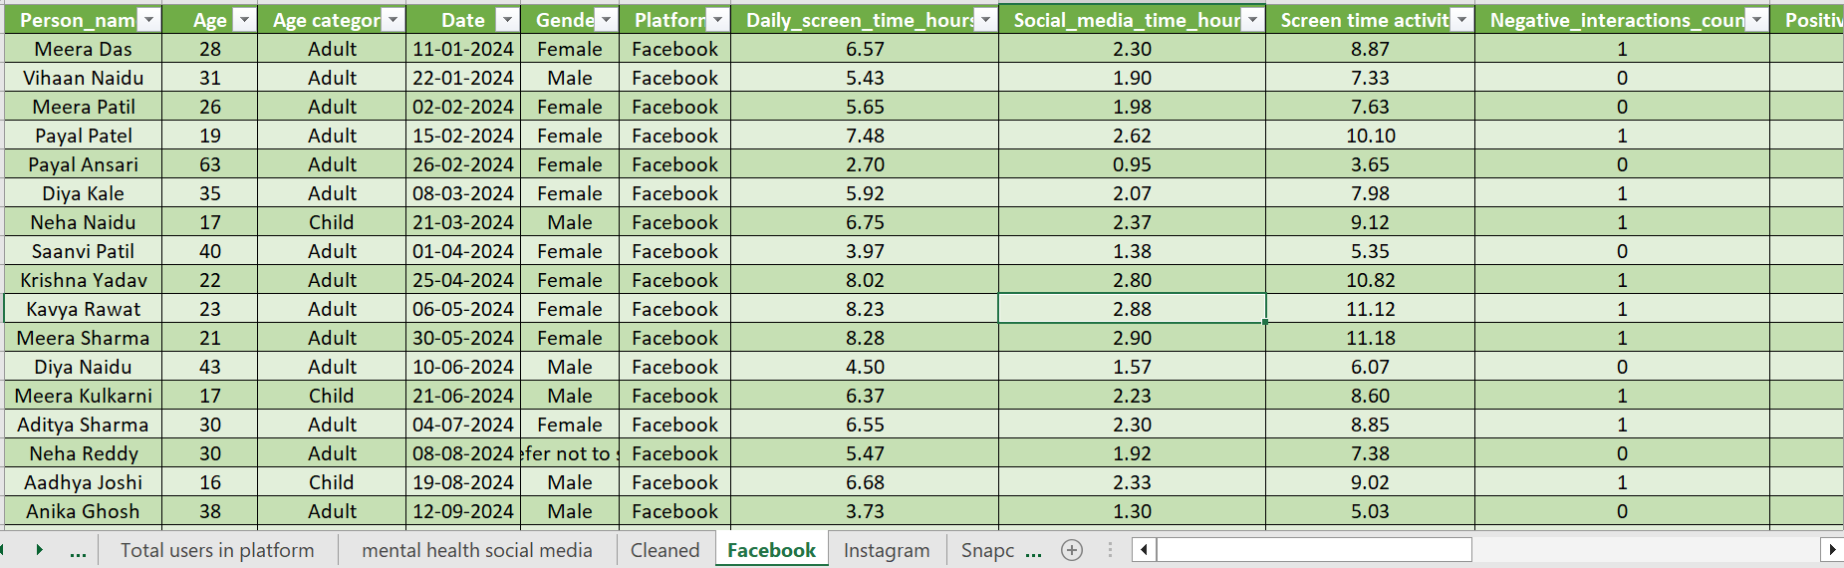
Instagram:

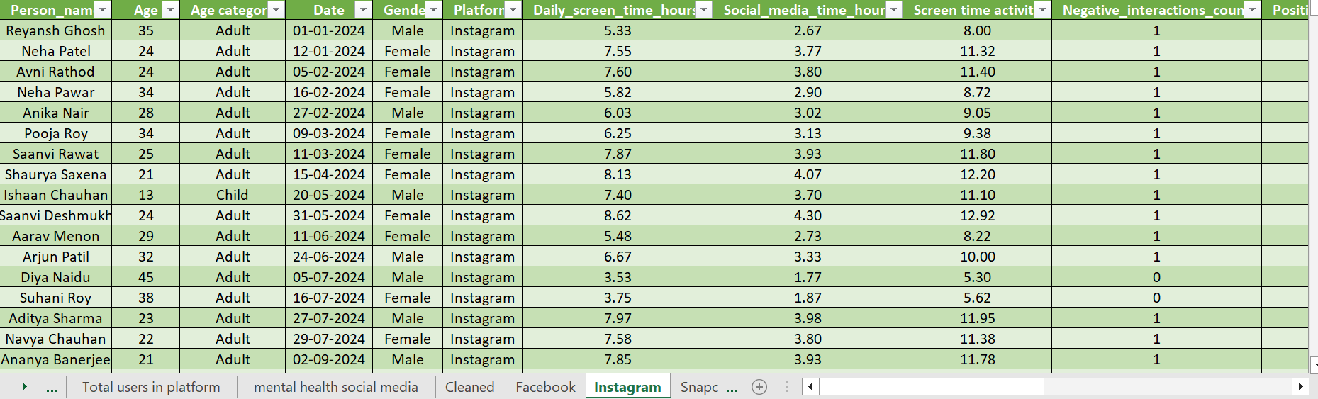

Snapchat:
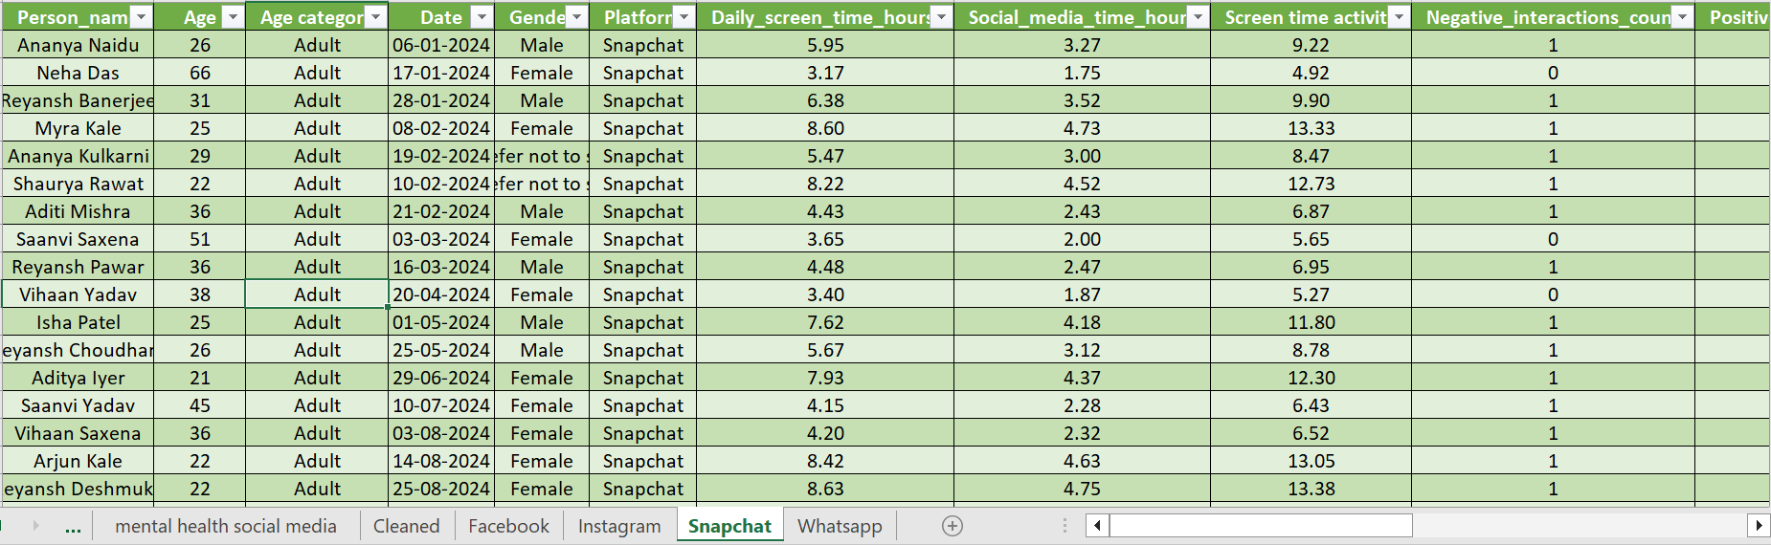

WhatsApp:
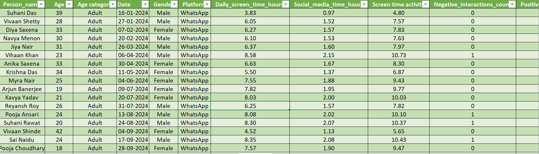

Visualization using Power Bi

Measures:
Average price of anxiety level: The average anxiety level among users is 2.51, indicating generally low anxiety levels in the dataset. This suggests that most individuals experience mild or manageable anxiety based on the collected responses.
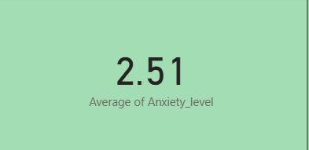

Average Mood level: The average mood level is 5.63, indicating a generally moderate and stable emotional state among users. This suggests that most individuals experience balanced mood levels with neither extreme highs nor lows.
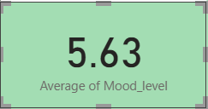

Charts:
Pie chart: Using to analysis count of sleep Quality
Findings: The chart shows that the majority of users (88.8%) have Normal sleep quality, while only a small portion report High (6.14%) or Poor (5.06%) sleep. Overall, sleep quality appears generally balanced with very few extreme cases.
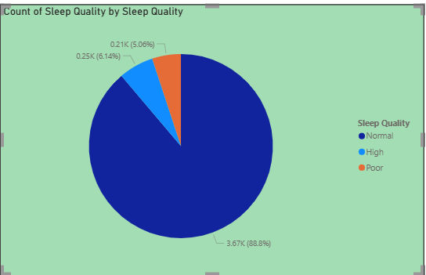
Donut chart: Used to analyze mental state of each user.
Findings: The visualization shows that a large majority of users (91.94%) fall under the Stressed category, while only a small proportion are Healthy (6.89%) or At Risk (1.16%). This indicates a high overall stress burden among the population in the dataset.
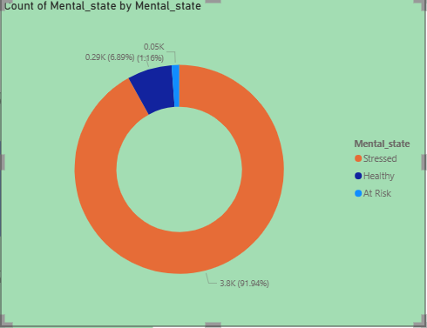

Line Chart: Used to analyze the stress level in each user.
Findings: The chart shows a clear downward trend where stress levels decrease as sleep hours increase. This indicates that individuals who get more sleep generally experience lower stress levels.
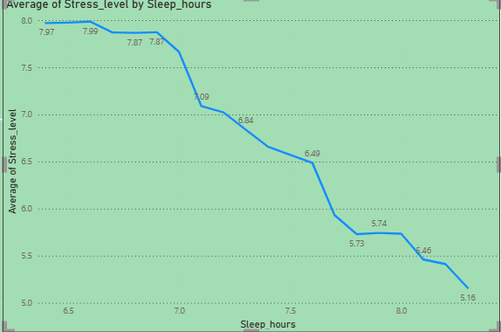
Funnel chart: Used to find out average screen time activity.
Findings: TikTok and YouTube show the highest average screen time, indicating they are the most engaging platforms among users. WhatsApp and Facebook have the lowest screen time, suggesting comparatively lighter usage.
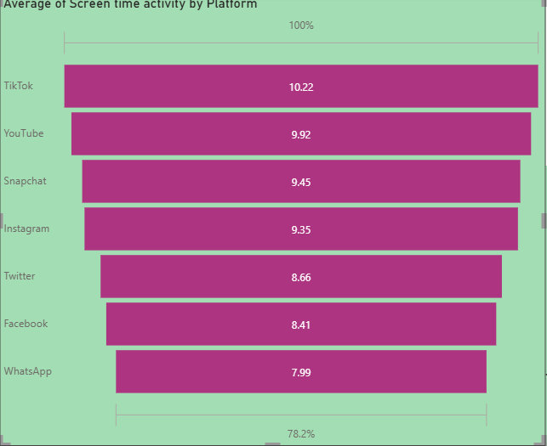
Clustered column chart: Used to analyze Positive interaction count by using platform.
Positive interaction chart:
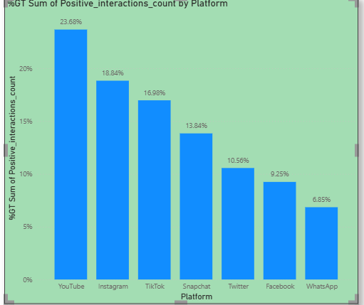

Stacked column chart: Used to analyze Negative interaction using platform
Negative interaction chart:
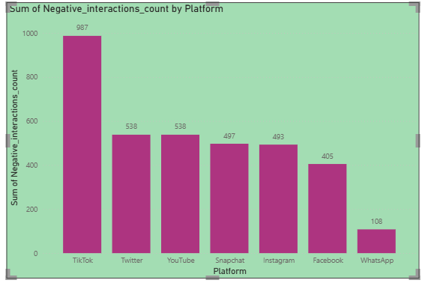

Slicers: slicers used by platform.
Findings: A platform slicer has been added to allow users to filter the dashboard by individual social media platforms. This enables interactive and focused analysis based on specific platform usage.
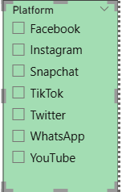

DASHBOARD
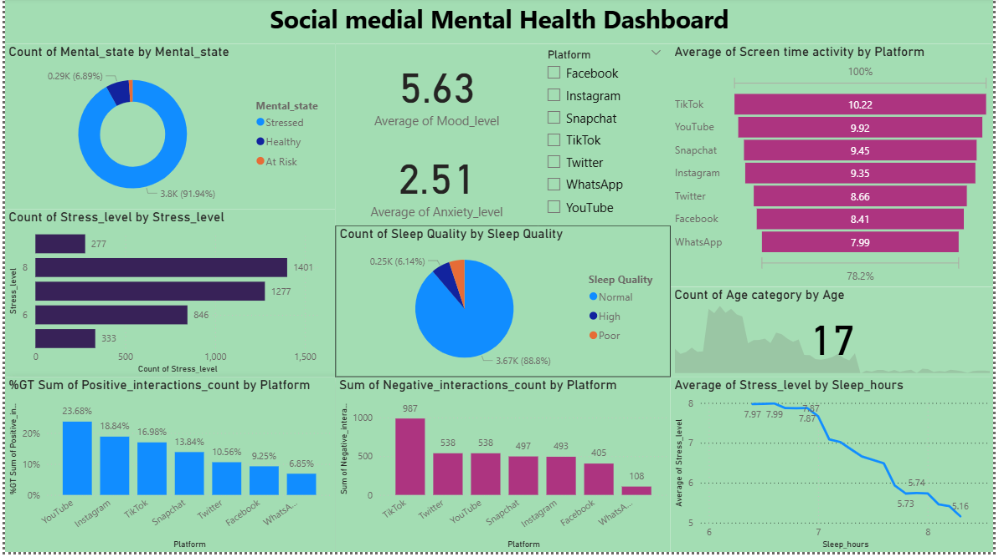

AFTER USING SLICERS IN DASHBOARD

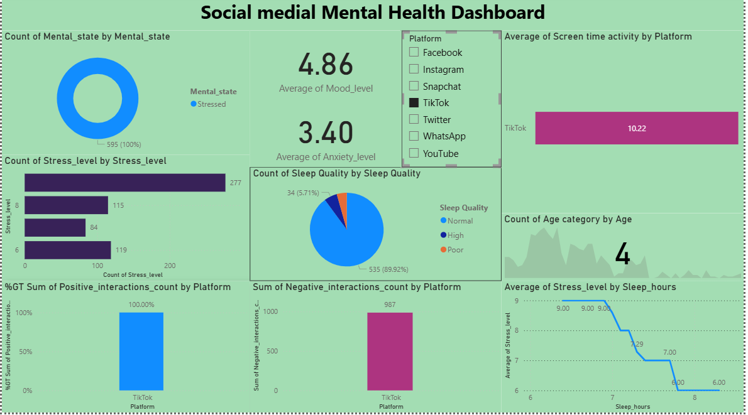

Insights:
- Stress decreases as sleep increases
The line chart shows a strong negative relationship between sleep hours and stress levels.
→ More sleep = Lower stress
→ Users getting 8+ hours of sleep show the lowest stress levels.
- Most users have Normal sleep quality
Nearly 89% of users have Normal sleep, with only small portions experiencing high or poor sleep quality.
→ Sleep is not a major issue for the majority.
- Mental health concern: Majority of users are stressed
The donut chart shows 91.94% of users are classified as Stressed, with very few being Healthy or At Risk.
→ This indicates a high mental burden across the population, despite normal sleep patterns.
- Average anxiety level is low
The average anxiety score is 2.51, indicating mild anxiety for most users.
→ Anxiety is not the primary contributor to mental distress.
- Mood levels are moderate
The average mood score of 5.63 indicates that most users are in a balanced emotional state, neither highly positive nor negative.
- TikTok and YouTube drive the highest screen time
The funnel chart shows:
- TikTok → Highest average screen time
- YouTube → Second highest
- WhatsApp & Facebook → Lowest
→ Platforms with more entertainment-focused content show longer engagement.
- High screen time may be contributing to stress
Since a majority of users are stressed, and some platforms show heavy screen time, it suggests:
→ High platform usage could be linked to higher stress levels, especially for TikTok and YouTube users.
- Slicer enables focused analysis
The platform slicer makes it possible to analyze:
- Stress by platform
- Sleep by platform
- Interaction levels
- Mood and anxiety comparisons

Conclusion:
The analysis shows that while most users have normal sleep quality, overall stress levels remain significantly high. Increased sleep hours are strongly linked to lower stress, highlighting sleep as a key protective factor. Screen time is highest on TikTok and YouTube, suggesting these platforms contribute to longer digital engagement. Children and adults show different patterns in social media usage, with adults generally spending more time across multiple platforms. Stress levels tend to be higher among adults, likely due to greater digital exposure and lifestyle pressures. Children show comparatively lower screen time but are still influenced by high-engagement apps. Overall, balanced sleep and mindful screen usage appear essential for improving mental well-being in this population.

